**Ex 1:**

Write a program that will display in the **HTML console** all the ODD the numbers between 200 and 250.

**Ex 2:**

Write a program that will display in the **HTML console** all integer numbers between 200 and 300 and will put the text “Here is a fiver: ” in front of the numbers that are divisible by 5. Sample output:

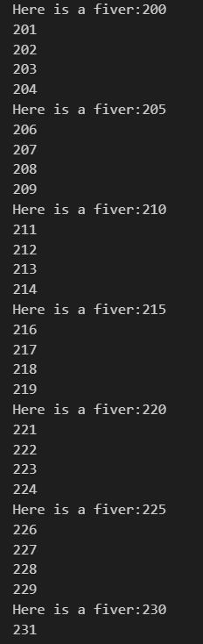 … Up to 300

**Ex 3:**

Change the exercise 2 such that you put the text “Non 8er” in front of all numbers NON divisible by 8! **You may keep OR remove the text “Here is a fiver “… I would prefer having it!**

**Ex 4:**

Write a program that will display in the HTML console the list of the first 20 Fibonacci numbers.

**Ex 5:**

Write a program that will display in the HTML console all Fibonacci numbers up to 1 000 000. How many numbers have there been displayed? (Find the count through code… DO NOT count them manually).

**Ex 6:**

In the above list (Ex 5) put the word “Even“ in front of all even numbers.

**Ex 7:**

You are given an HTML page with the following contents:

<!DOCTYPE html>

<html>

<head>

    <meta charset='utf-8'>

    <title>Page Title</title>

    <link rel='stylesheet' type='text/css' media='screen' href='main.css'>

    <script src='main.js'></script>

</head>

<body onload="startCode();">

    <table id = "myTable">

    </table>

</body>

</html>

The css file named main.css has the following contents:

.redCells{

    background-color: red;

}

.yellowCells

{

    background-color: yellow;

}

Create a main.js file with a JS script that will do the following:

1. Add 5 rows and 8 columns to the HTML table.
2. Inside each cell of the HTML table write the product of its row and column index.

The output should be:

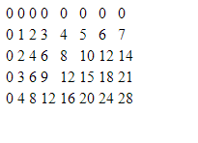

1. Color each second ROW of the above table in yellow:

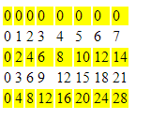

1. Color each second column in the above table in red:

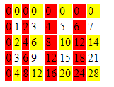

**Ex 8:**

Create a new HTML page with the following contents:

<!DOCTYPE html>

<html>

<head>

    <meta charset='utf-8'>

    <title>Exercise 2</title>

    <script src='main.js'></script>

</head>

<body onload="startCode();">

    <div id ="dataHere">

    </div>

</body>

</html>

**You do not use any css code for this exercise!!**

Your initial main.js file looks like this:

function startCode()

{

    m = 50;

    // write code here

}

1. Complete the above code such that, you put inside the div with id “dataHere”, line by line, all the numbers from m (which is GIVEN to be 50) down to 0.
2. Assume m is changed to a negative number (for example -50). You should get an EMPTY div – no number should be displayed. **Note: if you implemented correctly point a) you do not have to write ANY code for this point. This is only an extra checking!**
3. **Change** the code such that when m is positive, you get a countdown to 0 AND, when m is negative you get a count UP to 0. **TRY** creating just ONE single loop in your code!

Example of different runs:

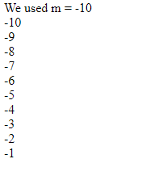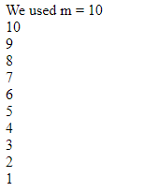

Deadline: Friday – 18th of October.